
Name: - ___________. | 2025-26
Class: - ____________. | Periodic Assessment - I | Time Allotted: - 60 minutes.
Date: - __________ . | Subject: -SST | Maximum Marks: - 50
General Instruction:
- All questions are compulsory.
- Write your answers neatly and legibly.
- Double-check your work before submitting your paper.
- Read the instructions for each question carefully.
- Write your answers in the provided spaces and boxes, and avoid crossing out or scribbling over your work
- Write you name, class details without fail.

Q. 1 – Choose the correct options (5)

1. Which of the following is part of India’s natural heritage?
a) Sari b) Mawphlang sacred forest c) Kathakali d) Zardozi
2. India has _______ languages recognized by the Constitution.
a) 20 b) 22 c) 24 d) 26
3. The brown region on the physical map denotes the _______.
a) Northern Plains b) Islands c) Northern Mountains d) Coastal Plains
4. Laterite soil is mainly used to make _______.
a) Bricks b) Paper c) Sugar d) Marble
5. The season characterized by winds full of moisture is called _______.
a) Summer b) Winter c) Monsoon d) Autumn

Q. 2 – Fill in the blanks (5)

- India’s cultural heritage includes ________, dance, music and art forms.
- The Peninsular Plateau lies to the ________ of the Northern Plains.
- ________ soil is rich in humus and found in the Northern Plains.
- The Great Indian Desert is also known as the ________ Desert.
- The study of soil is known as ________.

Q. 3 – Give an answer in one word (5)

- The process of removal of topsoil by wind or water is called __________.
- The state where Kathakali originates is __________.
- The sacred forest of Mawphlang is located in __________.
- The dry and infertile soil found in Rajasthan is __________ soil.
- The landform with many islands on either side of India is the __________.

Q. 4 – Rectify the false statements (6)

1. Desert soil is the most fertile soil in India.
__________________________________________________________________________________________

2. Alluvial soil is found only in the Great Indian Desert.
__________________________________________________________________________________________

3. India has 28 recognised languages.
__________________________________________________________________________________________

4. The Northern Mountains lie south of the Peninsular Plateau.
__________________________________________________________________________________________

5. Laterite soil is mainly found in the Northern Plains.
__________________________________________________________________________________________

- Zardozi is a form of dance.
__________________________________________________________________________________________

Q. 5 – Match the following (6)
Column A Column B
a) Kathakali 1) Black soil
b) Ustad Zakir Hussain 2) State where Kathakali started
c) Black soil 3) Tabla maestro
d) Peninsular Plateau 4) Southern India
e) Monsoon 5) Season of rainfall
f) Great Indian Desert 6) Thar

Q. 6 – Identify the picture and write its name (3)

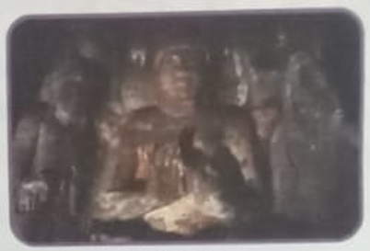Name: ________________________

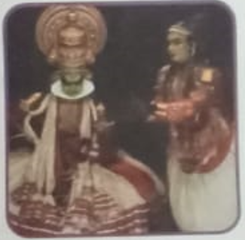 Name: ______________________________

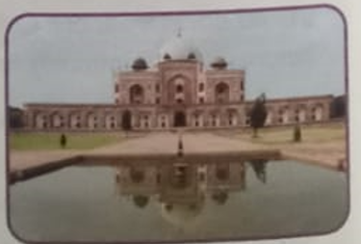 Name: _______________________

Q. 7 – Answer in One Word (6)
- What do we call the process of extracting minerals from the earth? ________________
- Which mineral, in liquid form, is used as fuel and is often called “black gold”? ________________
- Which mineral is the main source for producing aluminum? ________________

- Which metal is commonly used to make electrical wires? ________________
- Which non-metallic mineral is obtained by evaporating seawater? ________________
- Which fossil fuel, when burned, powers most thermal power plants? ________________

Q. 8 – Differentiate between two (4)

1. Differentiate between natural heritage and cultural heritage
2. Differentiate between alluvial soil and laterite soil.

Q. 9 – Case-based question (5)
Read the following case and answer the questions:
Rehana lives in Rajasthan and tried to grow a rose plant using sandy soil. Despite watering it daily, the plant did not grow.
a) Why did the rose plant fail to grow in sandy soil?
b) Which type of soil would be better for growing the rose plant?
c) Name one region where that soil is found.
d) Suggest one method to improve sandy soil fertility.
e) Mention one crop suited to sandy soil.

Q. 10 – Hot Questions (2)

1. Explain how the Northern Mountains influence the climate of India.

Q. 11 – Locate the following on the given map (3)
On the provided outline map of India, locate and label:
a) The Thar Desert b) The Peninsular Plateau c) The Northern Plains

Best of Luck

